CONTAINERS

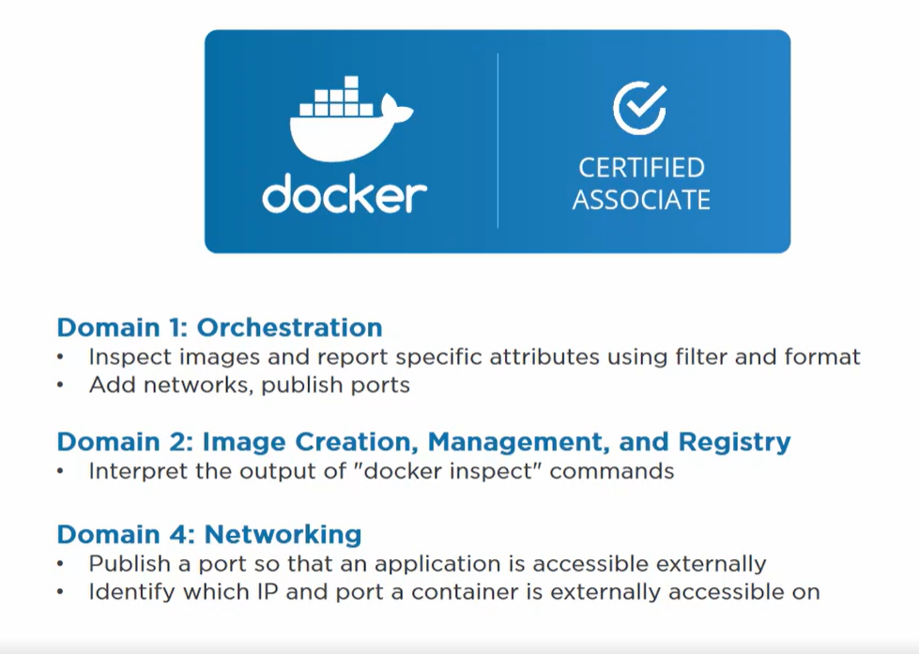

In Docker smallest unit of work is **container**.

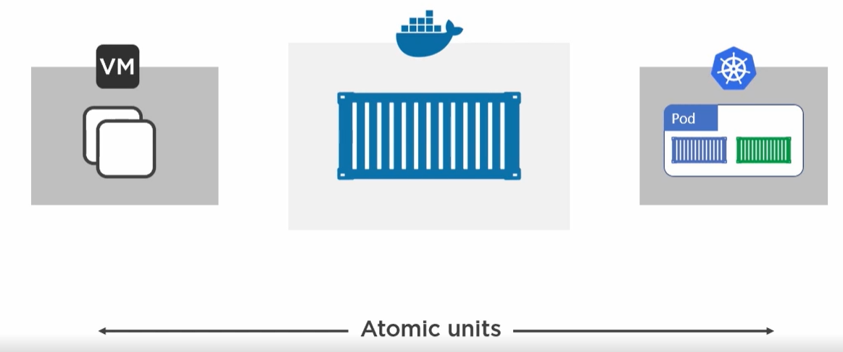

Container is a thin writable layer over images.

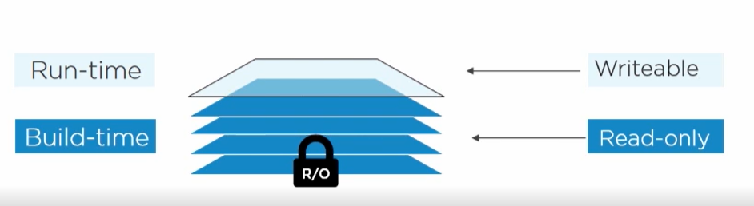

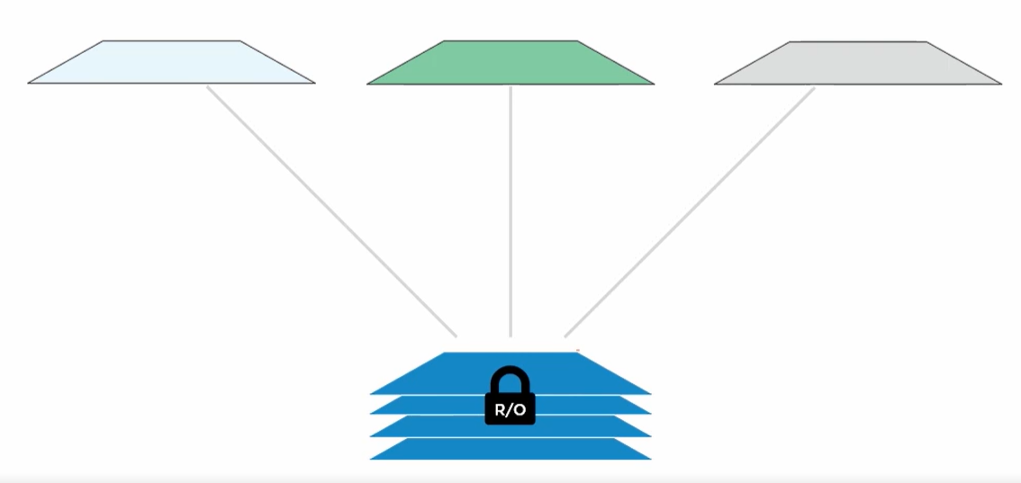

If a container needs to edit any file. It will not edit in image rather it will locate the file and copy in writable layer and then edit it.

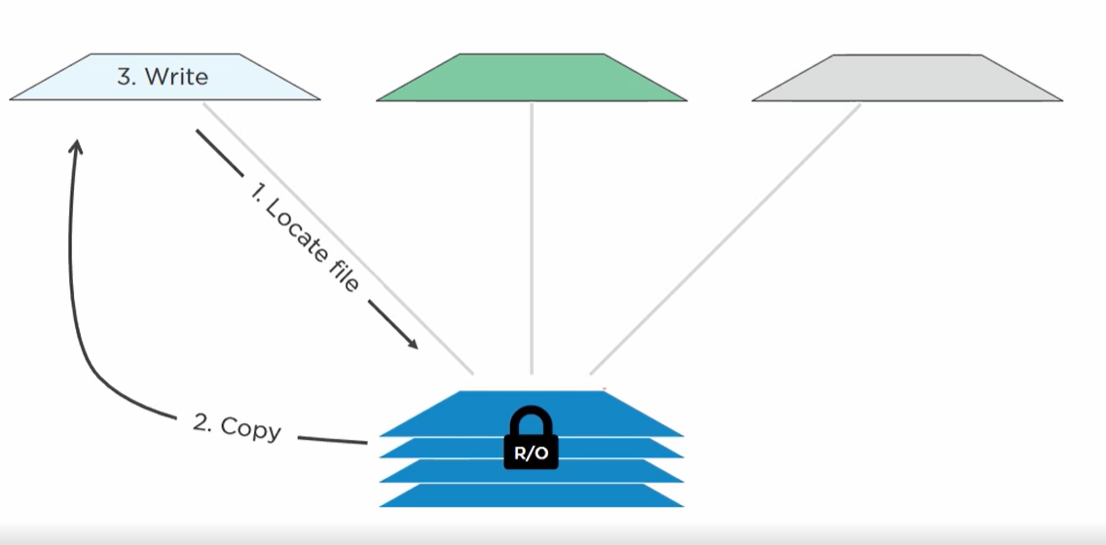

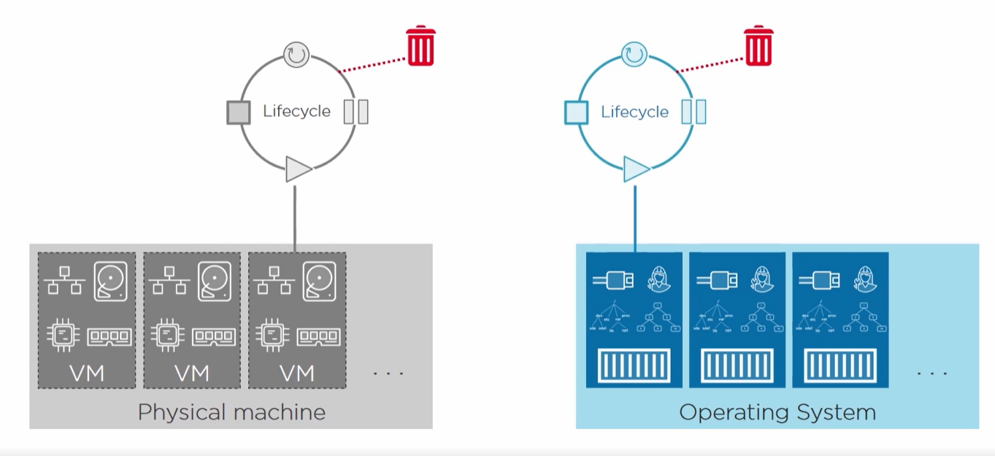

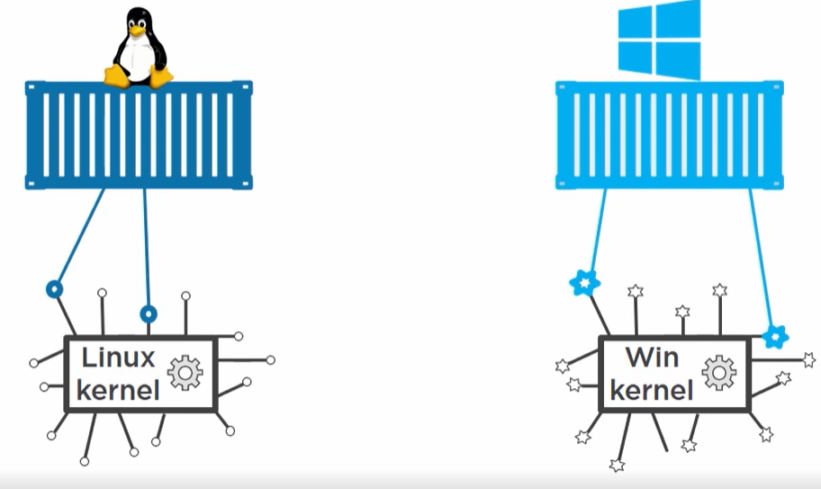

Linux container needs a linux kernel and windows container needs a windows kernel. Container doesn’t have its own kernel it shares the host kernel itself.

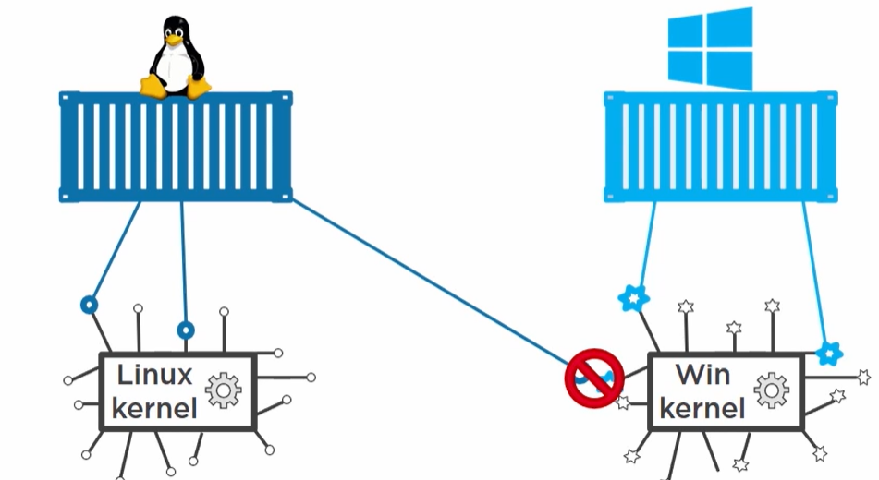

We can run a linux container on windows machine but it’s a virtual lightweight linux VM running on windows which make it happen and linux container are sharing kernel of virtual linux based OS and not of windows OS.

**Containers are best for microservices** with each service runs on separate container.

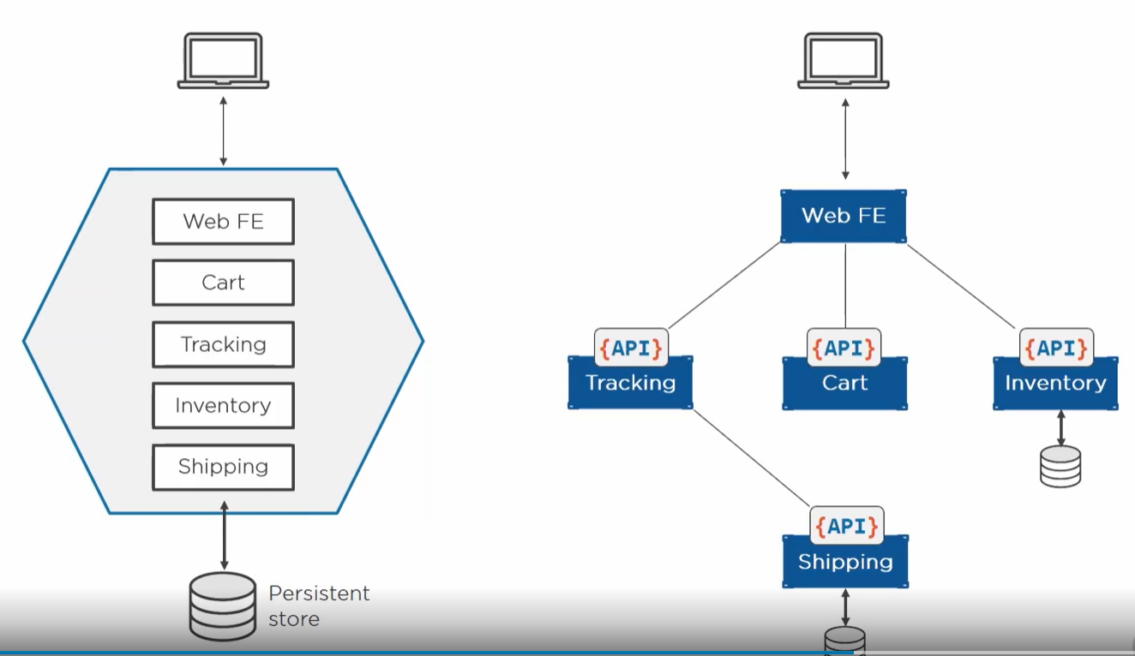

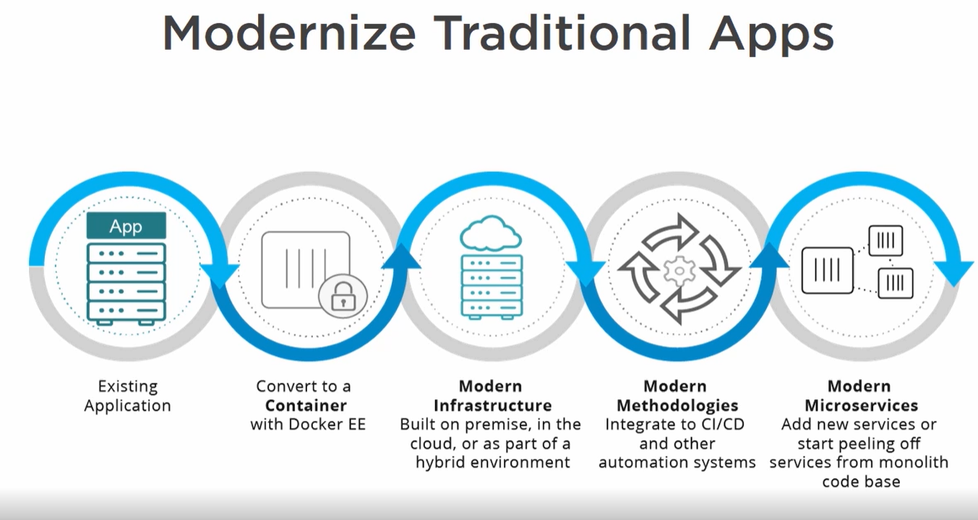

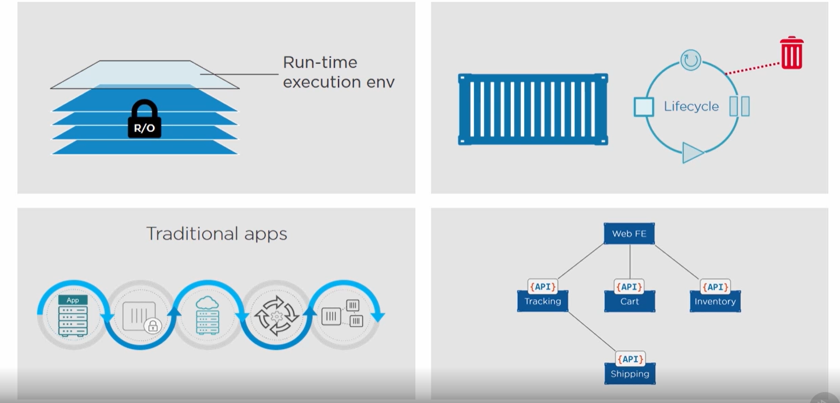

Docker run –name c1 -it imageName **sh**

This sh is process in which our container will run.

**Shell** is an interface between the user and the operating system, which helps the user to interact with the device.

**bash** is a superset of sh.

**Docker top containerName (to know the process)**

Linux ideally have one process per container but windows will have more than 1 process.

Linux process



Windows process

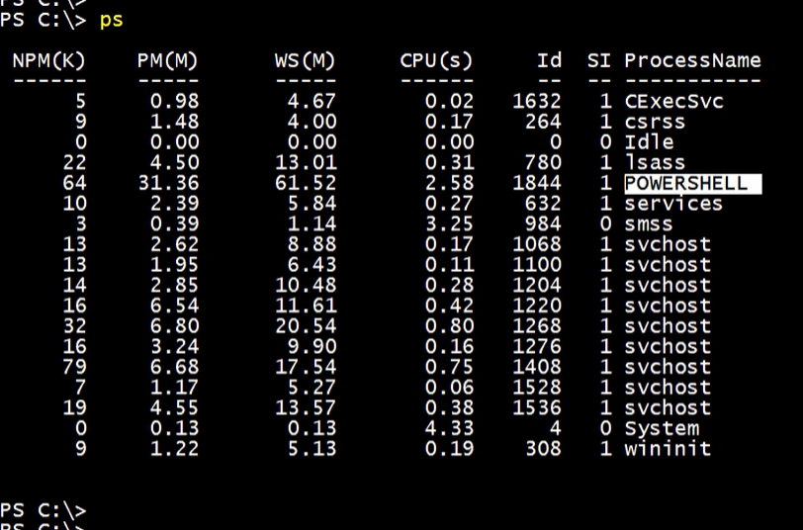

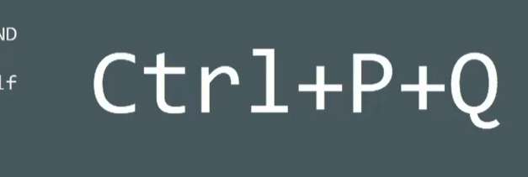

To get out of container.

To go inside running container:

Docker exec -it containerNAme sh

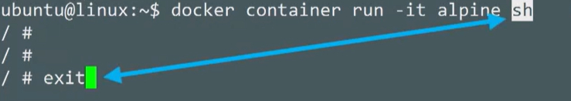

When we exit we are telling the shell process to exit and it will delete the container. Shell is actually the app container is running.

**We can also start container without giving any process like sh and bash:**

*Docker run –name containerName -it imageName*

Then the container will run in default process defined inside the image

Like if we do ***docker run –name c1 -it redisImage***

**It will run the process written inside redis image which is**

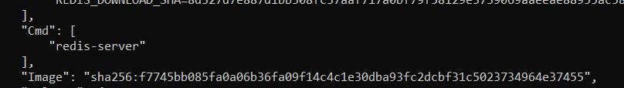

But as we write *docker run –name c1 -it image sh*

**It will override the cmd instruction written inside image**.

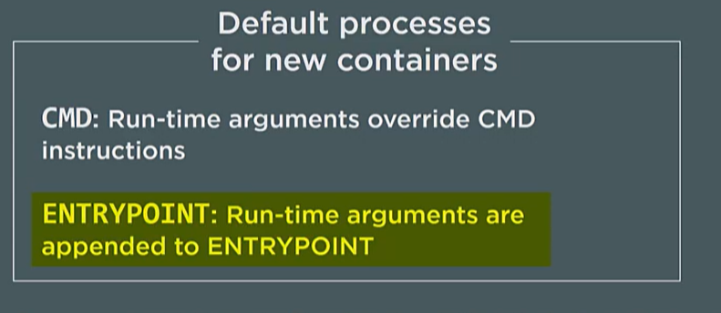

**WINDOWS CONTAINER:**

**Windows images are like**

mcr.microsoft.com/windows/servercore/iis

mcr.microsoft.com/windows/servercore/iis

docker run -d –name web1 -p 80:80 mcr.microsoft.com/windows/servercore/iis

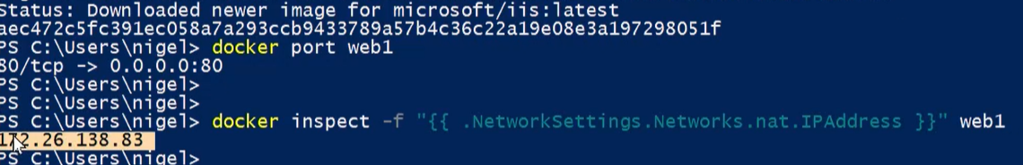

Getting ip of the container

**LOGGING**

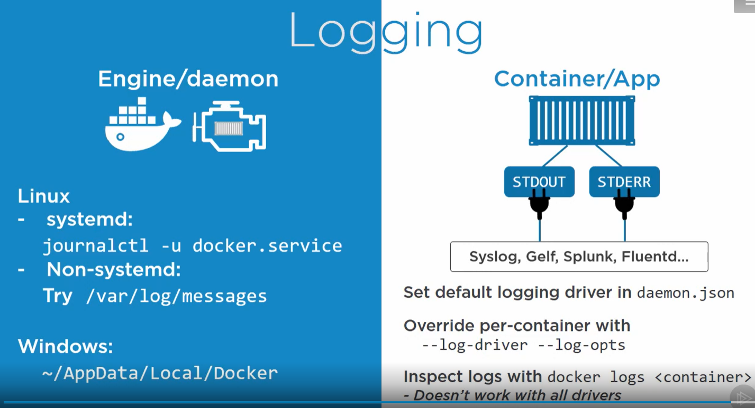

**2 types of logs:**

1. **Daemon logs**
2. **Container/App logs** – Docker hoping apps logs are STDOUT and STDERR. **Pid 1** process is getting captured and forwarded.

**Docker support idea of login driver** – It is plugin which integrate container login with existing login solution like splunk.

**DOCKER SWARM AND ORCHESTRATION**

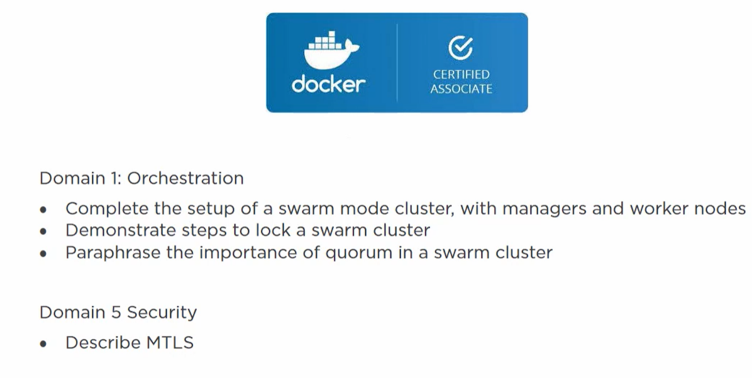

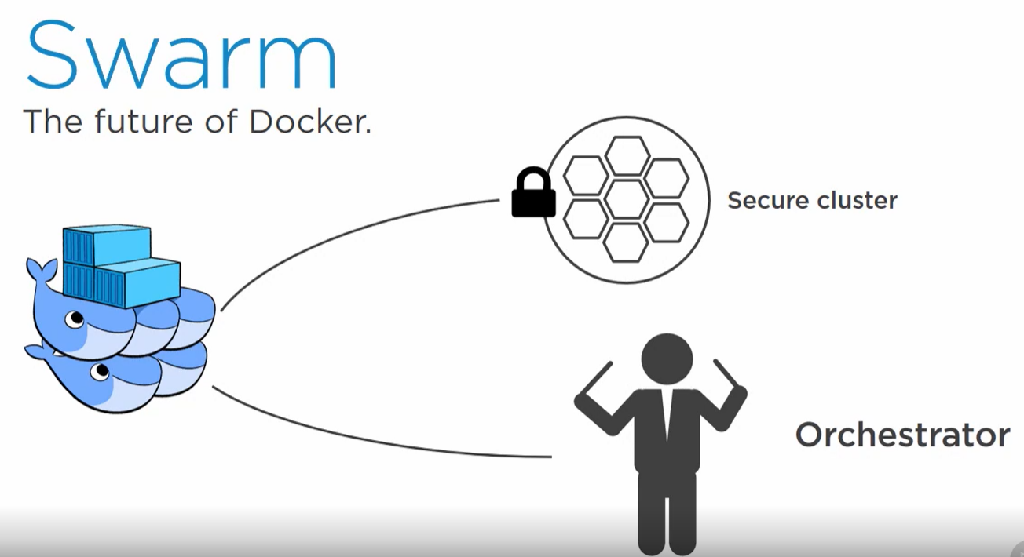

**SECURE SWARM CLUSTER**

**It is a cluster of docker nodes.**

* We got managers and workers and everything secure.
* We have Mutual TLS where managers and workers authenticate each other and all network encrypted.
* It has cluster store encrypted and distributed among all managers.

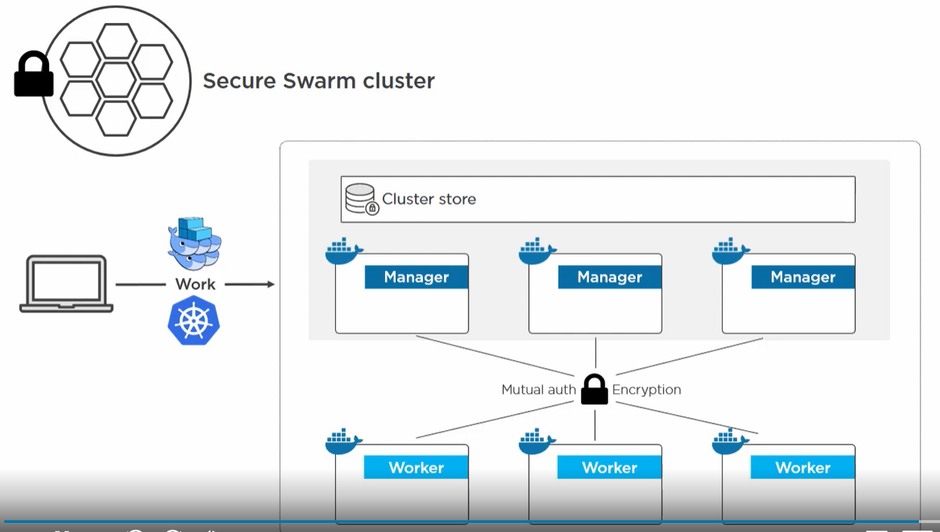

Once we create a swarm then we can start scheduling containers to it. Instead of manually running a container run command on a particular node.

We just throw the command to the cluster and lets swarm decide which node to run container on. It does the **load balancing**.

Now we can run 2 types of work in a cluster:

1. Native swarm work
2. Kubernetes work – on docker enterprise edition.

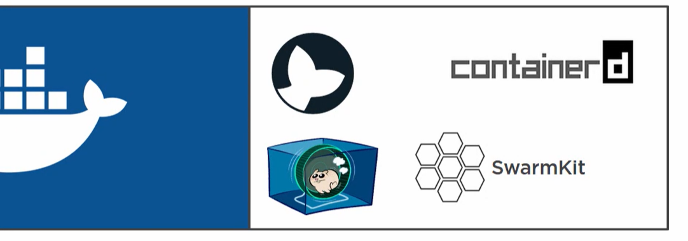

Docker tool bundles and integrate different tools like containerd , runc, Moby engine , swarmkit and packages together.

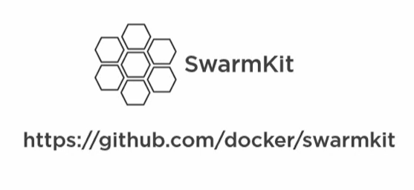

**Swarmkit**

One of the tool in docker which enables swarm mode. It got introduced in docker from v1.12+

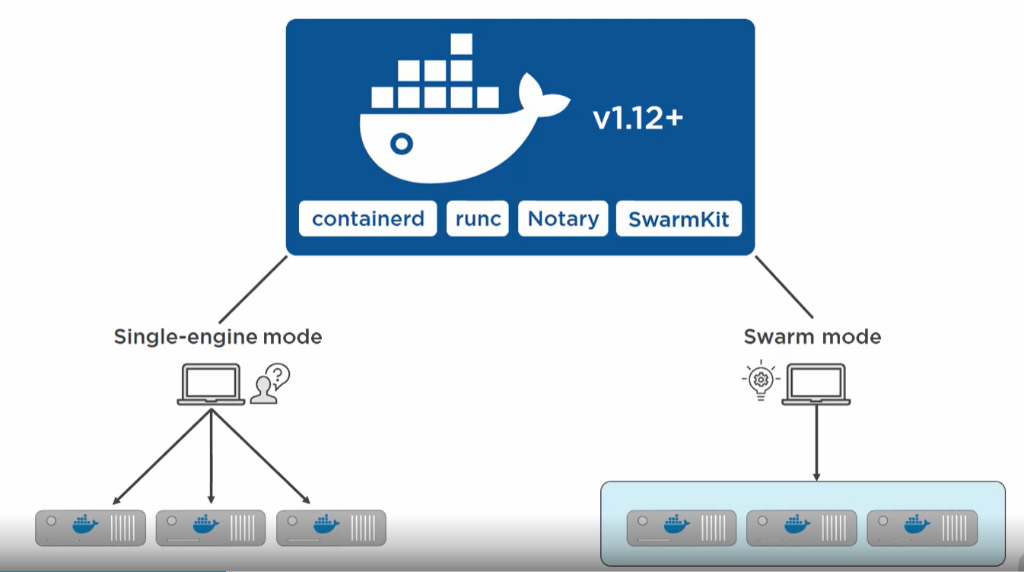

Since its introduction docker has 2 mode

1. **Single engine mode** – Where we install individual docker instance and work with them separately.
2. **Swarm mode** – Where multiple instances are cluster together and we throw work to cluster instead of working individually with a node.

Any node working in a swarm cluster we call it swarm mode.

Not working in swarm mode we call single engine mode.

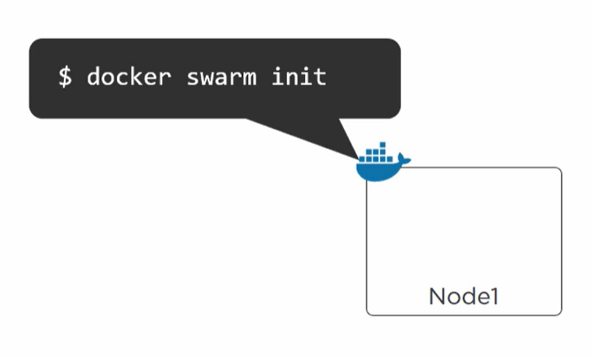

We have a **node1** where docker is installed. When we run a **docker swarm init** command then the node running in swarm mode and we get a swarm.

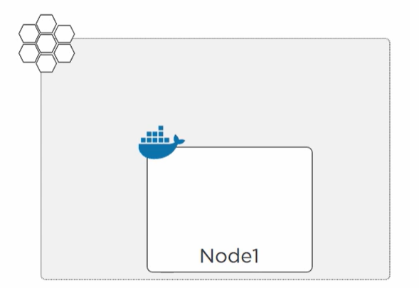

Now this is the first node so it will act as a manager and a leader.

**MANAGERS**

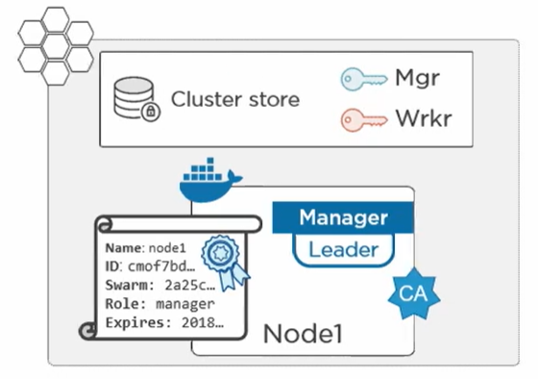

* It becomes the **root certificate authority**(CA).
* Manager does all control panel work , it does not run actual application.
* The manager gets a client certificate and builds a cluster store which is distributed among all managers and its encrypted.
* It creates a cryptic join token for manager and worker.
* We can join a single engine mode instance by running docker swarm join key command and it becomes part of swarm.

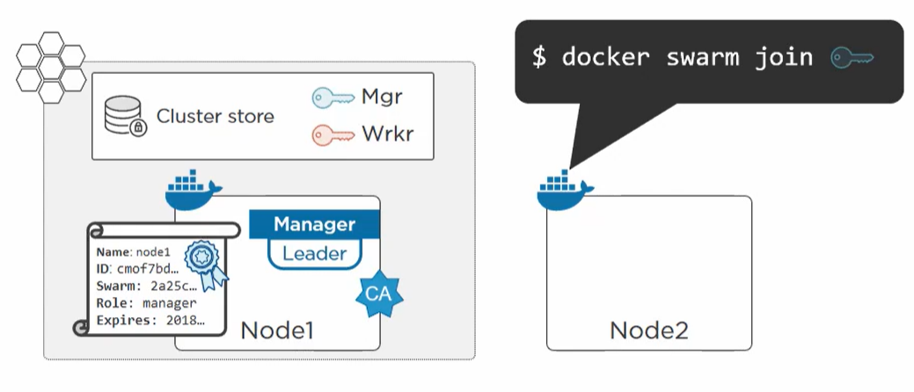

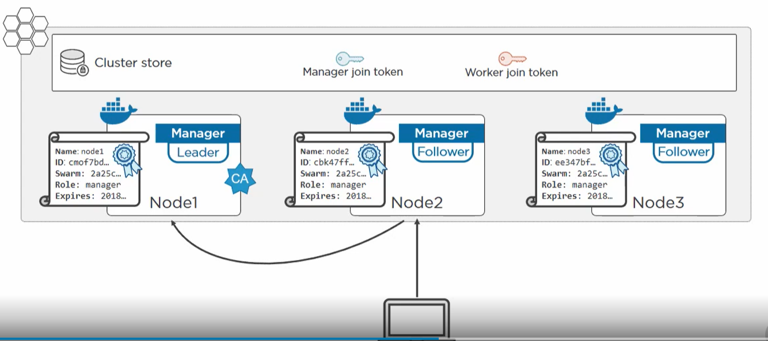

We can issue work to any manager and if we issue it to follower it will route to the leader.

If manager fails any of the follower becomes the leader.

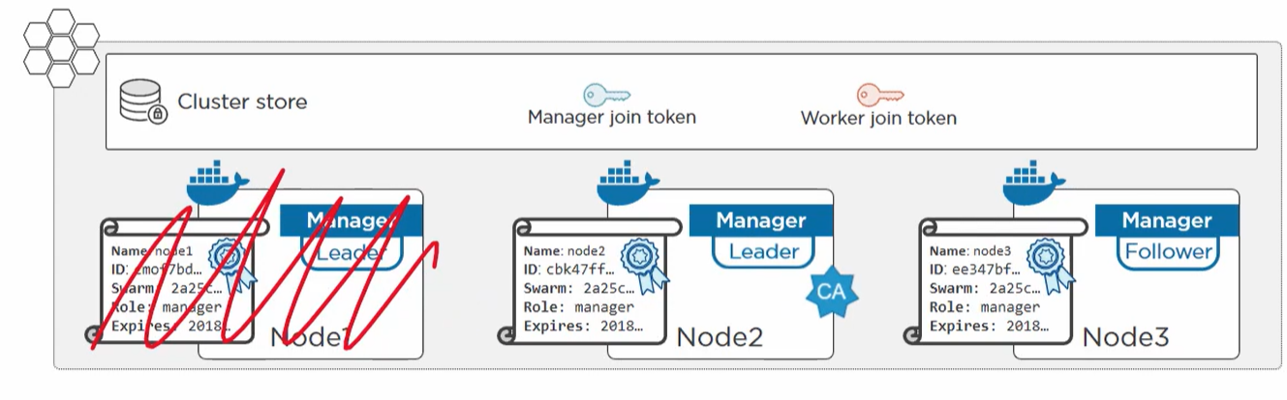

All these distributed consensuses are done by **RAFT.**

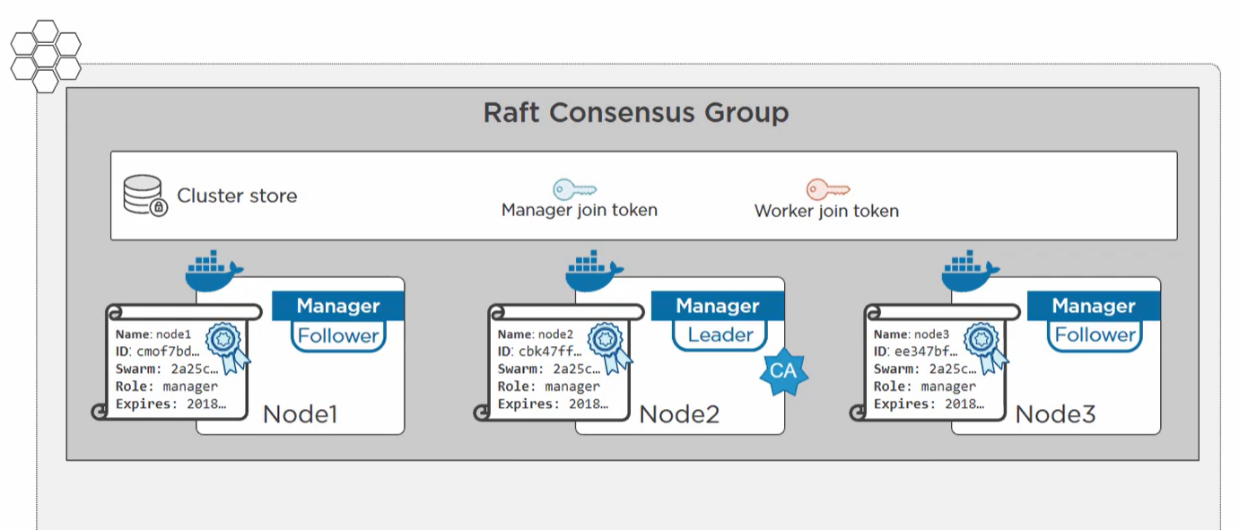

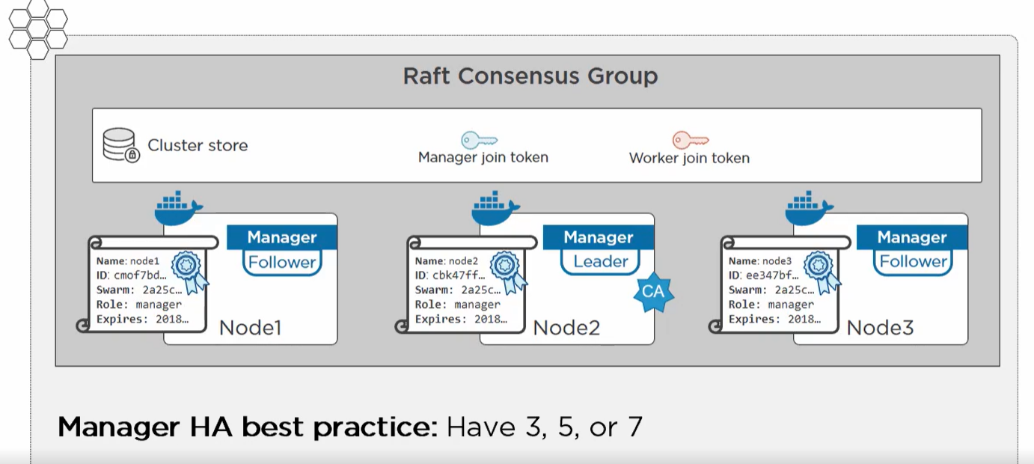

Manager number should be odd which helps keeping the quorum and get a majority and avoid split brain issue.

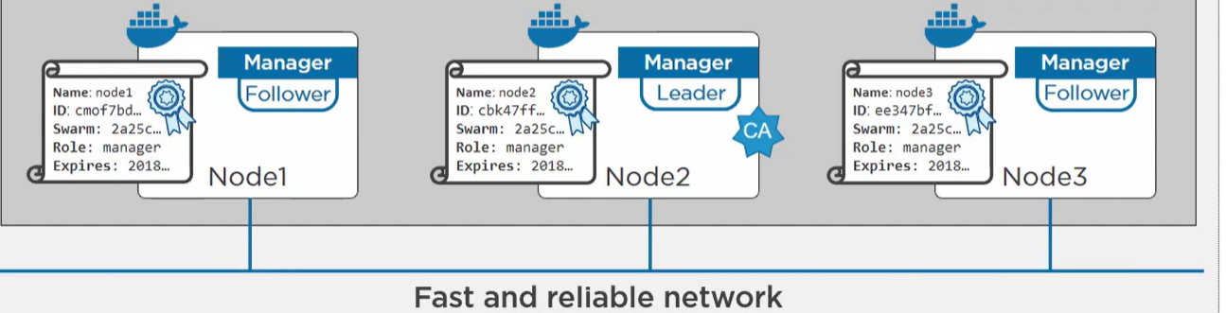

The network should be fast and reliable ex. If we are using amazon ec2 service don’t build swarm with different cross regions .

**WORKERS**

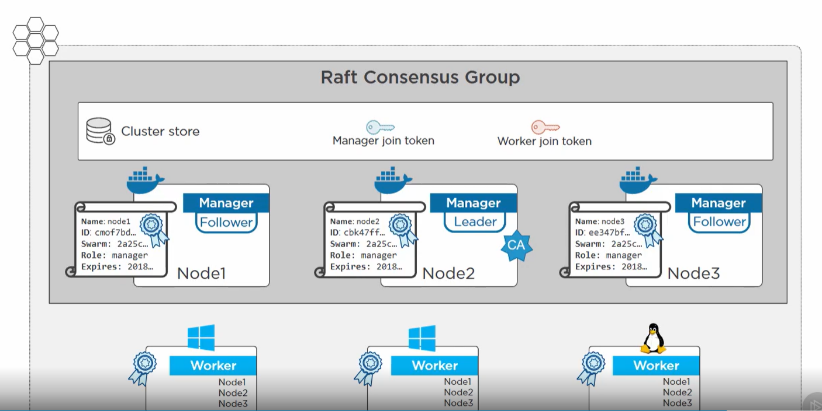

Workers don’t get cluster store access but gets IP of all managers. And gets its certificate as well.

Certificate tells who worker is, which swarm its member of and what its role.

All application work is done by the workers (native swarm work or kubernetes)

Workers cannot do **docker node ls.**

**To see the certificate.**





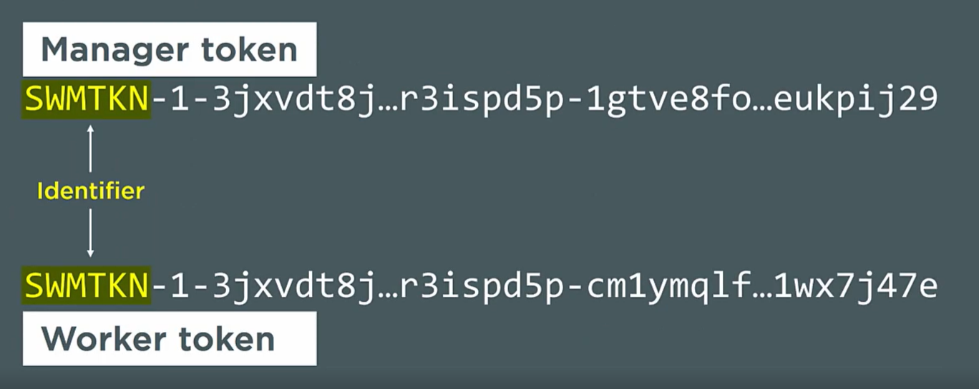

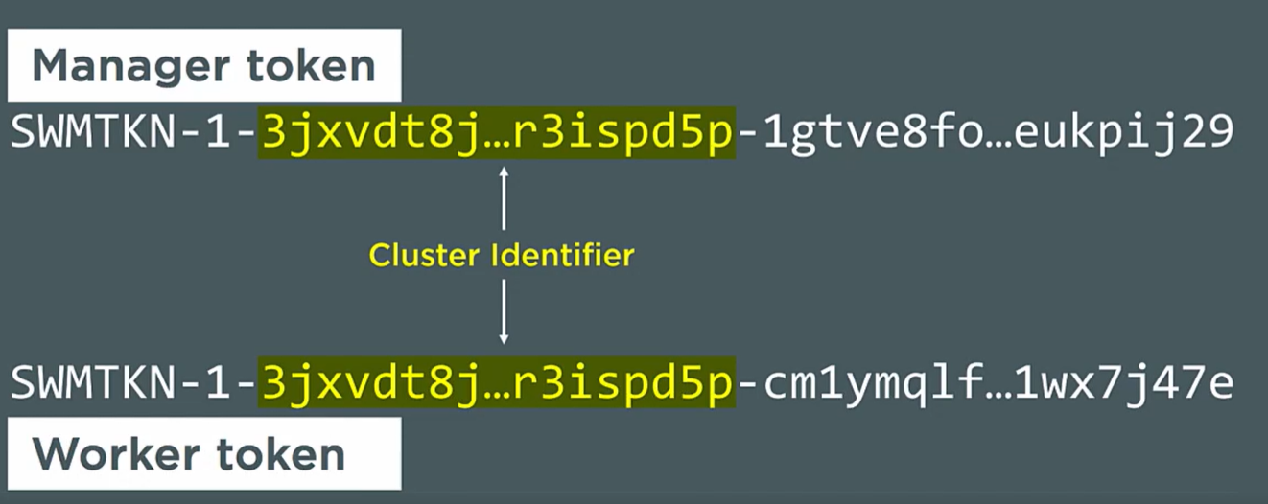

Hash of cluster certificate.

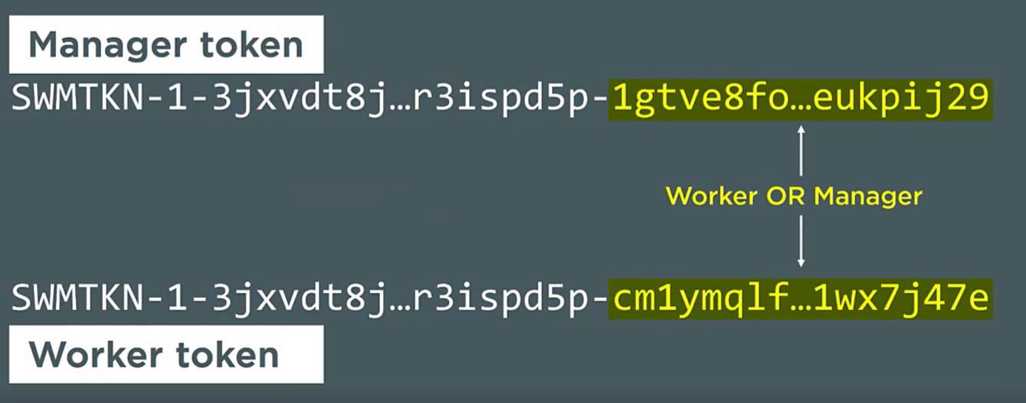

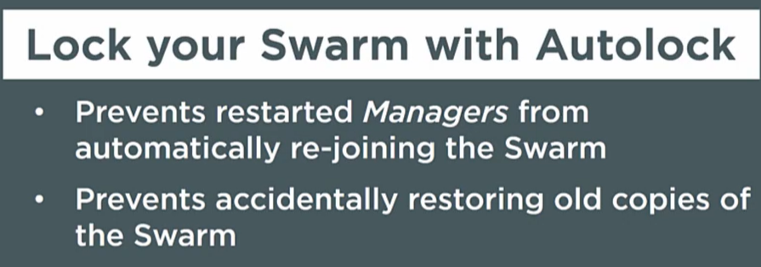

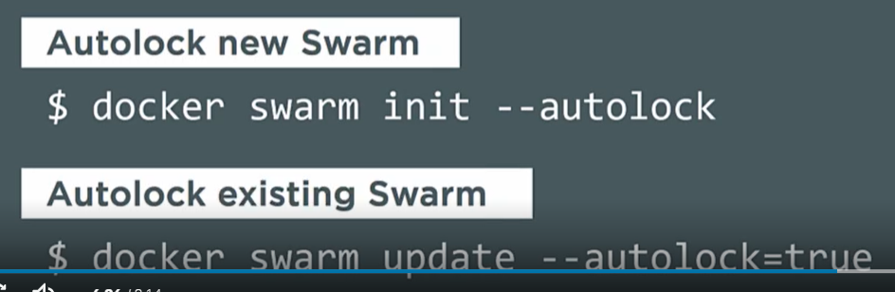

After locking when we try to do **docker node** ls we will have to unlock first.

Docker swarm unlock



**ORCHESTRATION**

When we have many nodes and hundreds of containers in a cluster maintaining them manually is hard process, hence we need some kind of orchestration tool like Docker Swarm or Kubernetes.

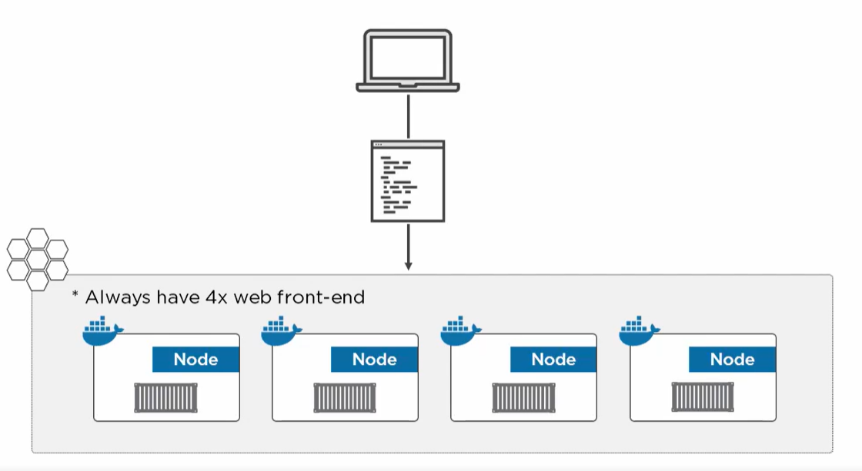

* Suppose we have a swarm of 4 nodes and we need to deploy our application on to it.
* So, we declarative say swarm to run our app making sure it has 4 containers always running the application.
* Once it deploys the app it records the desired state of 4 containers and always observing the cluster.
* If anytime the actual state is different from desired state maybe a node fail and we drop from 4 container to 3. So swarm/ kubernetes will step in and selfheal create one more container.

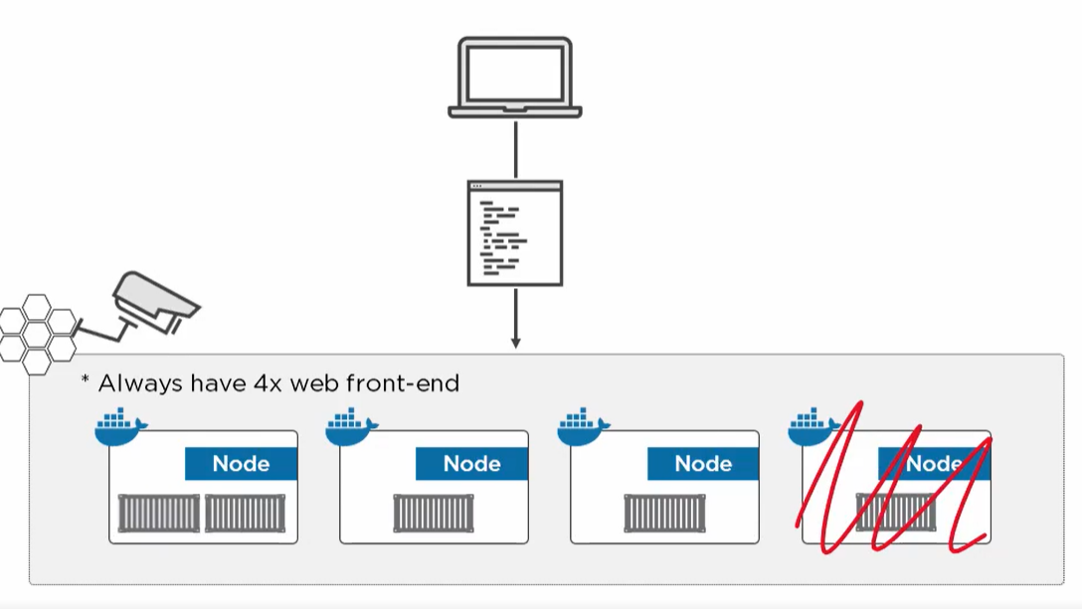

Other task of orchestration is balancing the load and rolling updates etc.

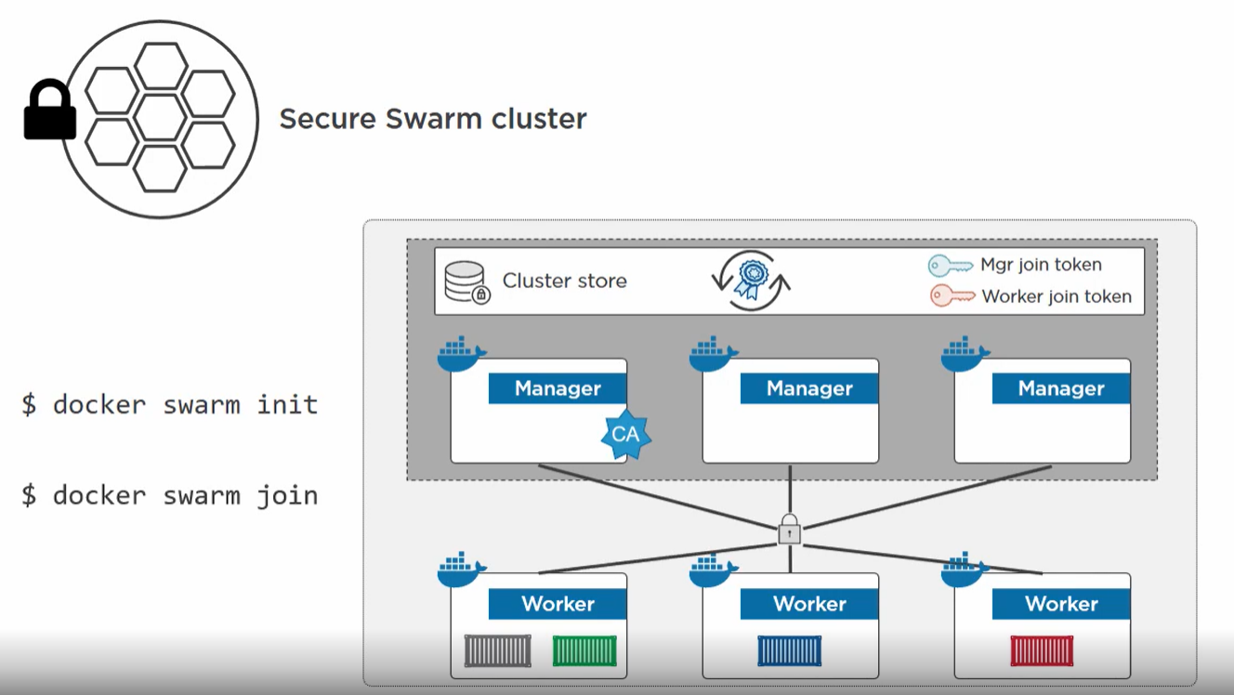

* Mutual TLS
* Secure cluster store
* Certificate rotation
* Encrypted join token